**Homework: Fabian LeFevre**

1. Make sure all screenshots asked for in the lab manual have been provided.

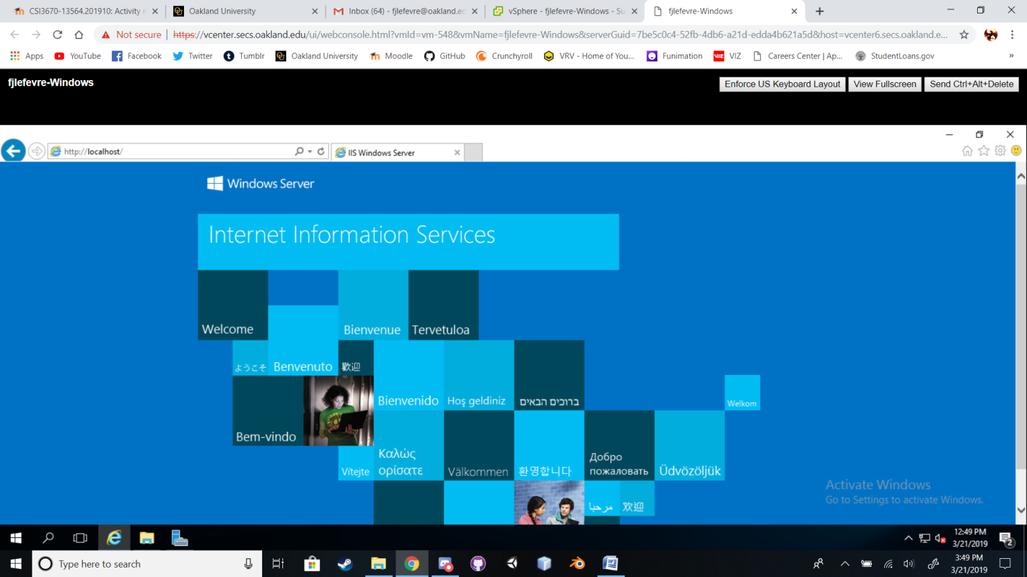

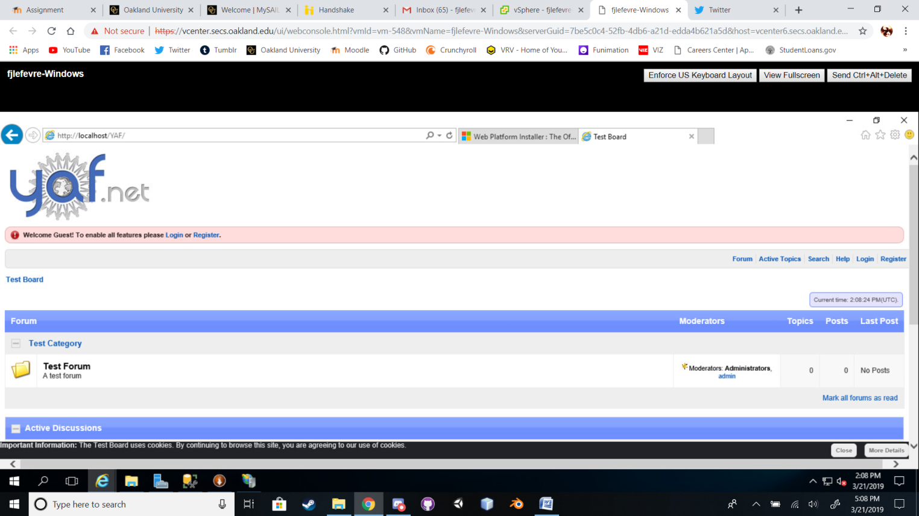

1. What are two differences (**other than cost**) between SQL Server and SQL Server Express Edition?

**Express is for limited applications such as data management web servers. (Like our forums we created in this lab)**

**Standard is for more robust applications and provides more features, such as security and other capabilities.**

1. What is a default website in IIS? If you wanted to create a new default website (not using the existing default website), what steps are required to do so?

**A default website in IIS is the main site or web application that is loaded when connecting to the Windows Server through a web browser.**

**Steps to create a new default website:**

**Open IIS management console in the Tools menu.**

**Click “Stop” on the current Default Website.**

**Right click on Sites and click ‘Add Website’**

**Configure these:**

**Site name: <something>.com**

**Application pool: Same as site name**

**Physical path: “C:\IIS**

**Type: http**

**IP Address: All Unassigned**

**Port: 80**

**Host Name: <something>.com**

1. Describe the differences between Digest, Forms, and Windows authentication for IIS applications/sites.

**Digest – Utilizes secret keys that are not sent across a network and is used when full encryption is not a necessity.**

**Forms – Web form used for login (EX: Sharepoint and Exchange Web App)**

**Win Authentication – Uses AD DS. The Server and client will most likely end up using Kerberos as a network authentication protocol. NTLM is possible, but deprecated.**

1. What is an application pool?

**An application pool defines a group of one or more worker processes that are configured to server requests to applications assigned to the pool.**

1. Assume that you wanted IIS to run PHP pages. What would you have to do in order to serve PHP content?

**Need to install PHP, then configure PHP settings and lastly configure PHP Application Security.**

(<https://docs.microsoft.com/en-us/iis/application-frameworks/scenario-build-a-php-website-on-iis/configure-a-php-website-on-iis>)

1. Create some subforums for your project team and screenshot them. Make a sample post and screenshot that too.

